**Edge Filter for image processing [ Roberts, Sobel , Scharr, Prewittm,**

**Farid and Canny ]**

1. **Read our image :**

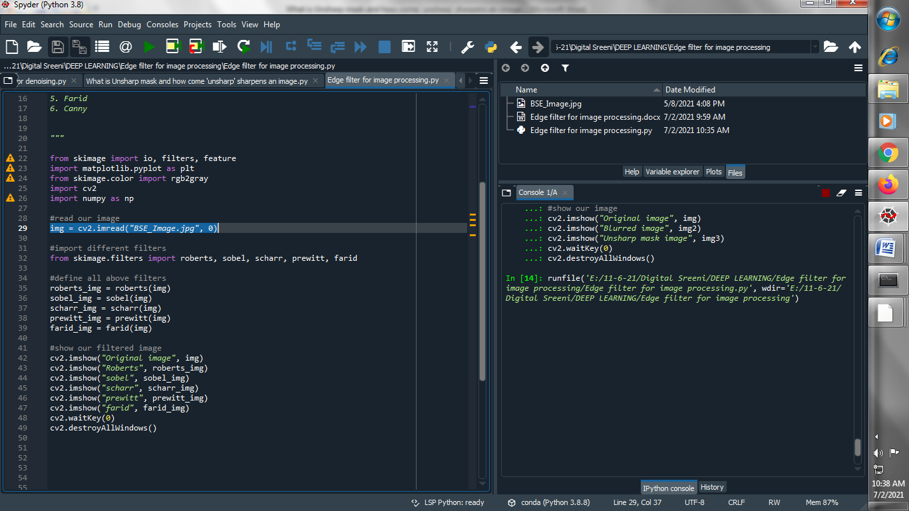

1. **Import different edge filters :**

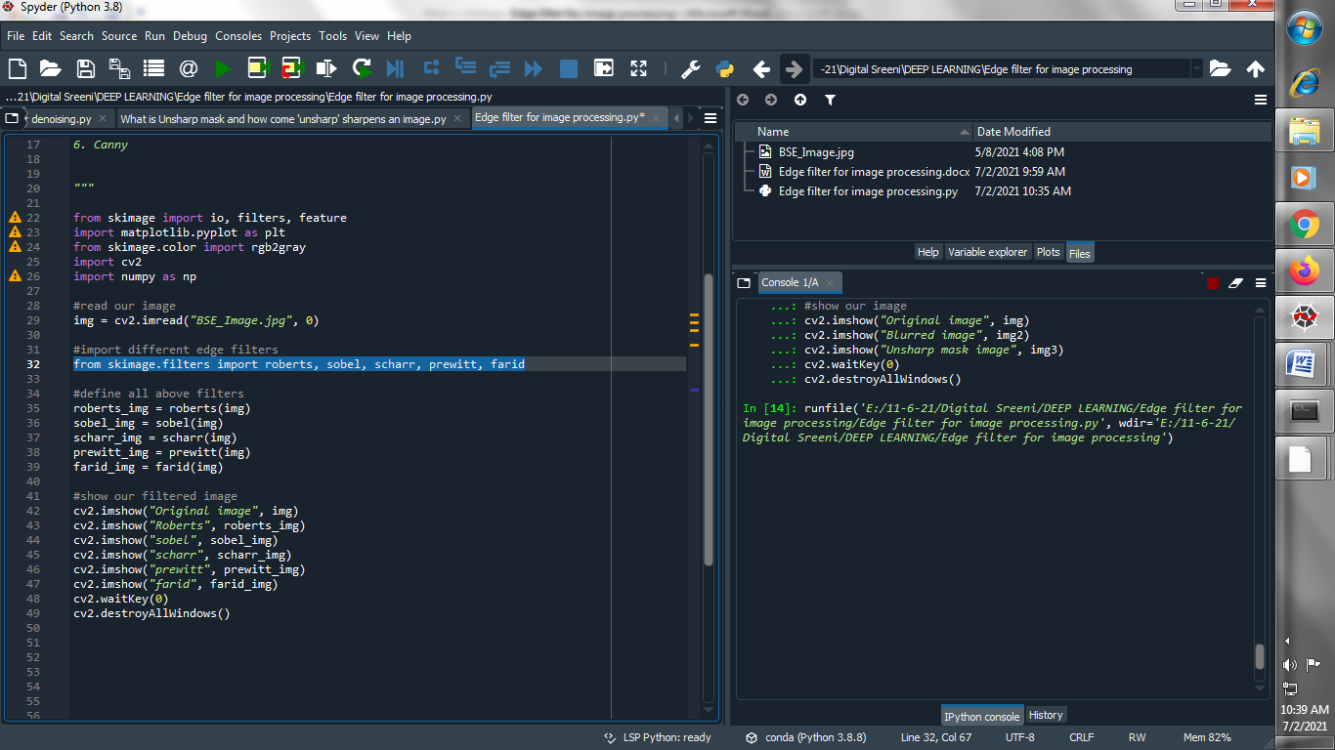

1. **Define above all edge filters :**

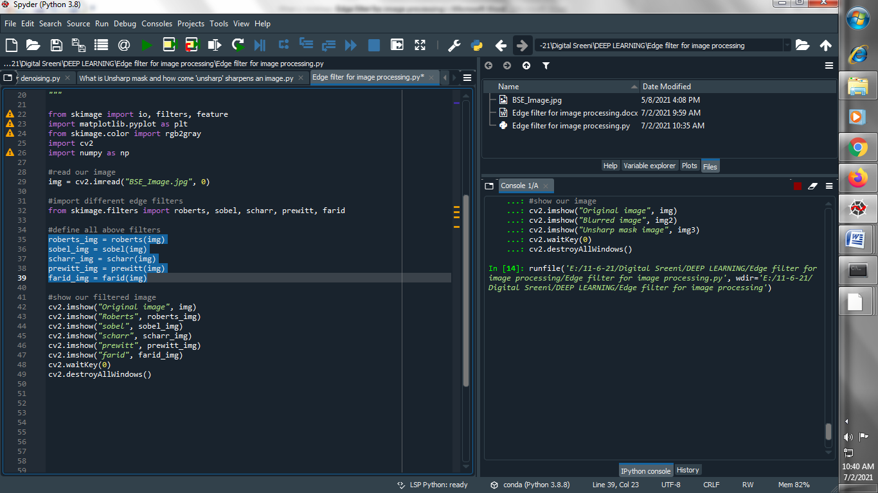

1. **Show above all edge filters :**

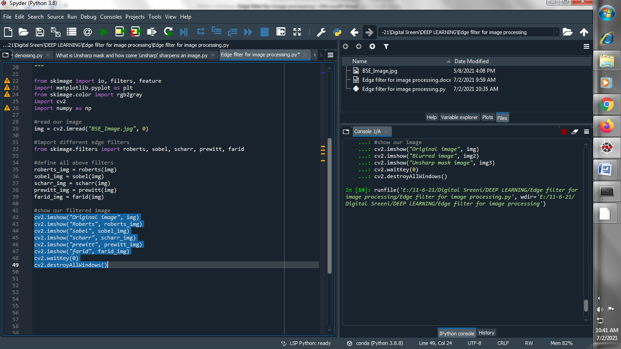

**Output :**

**→ Original image :**

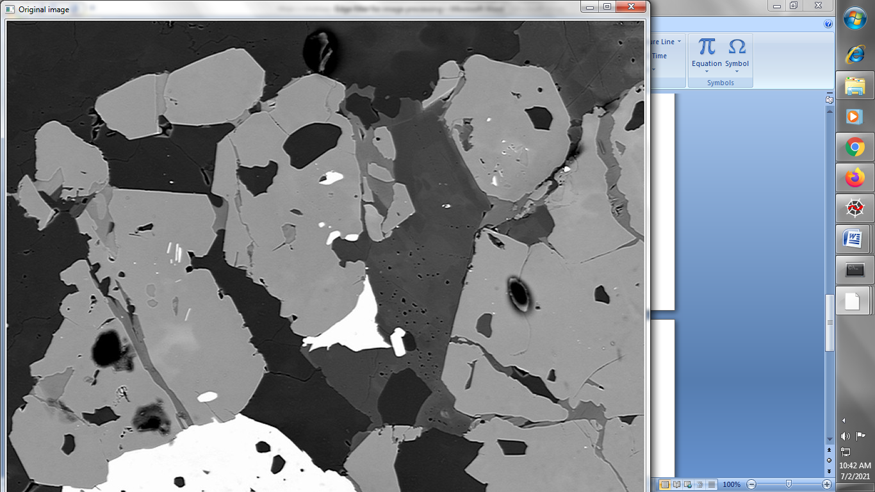

**→ Roberts filter :**

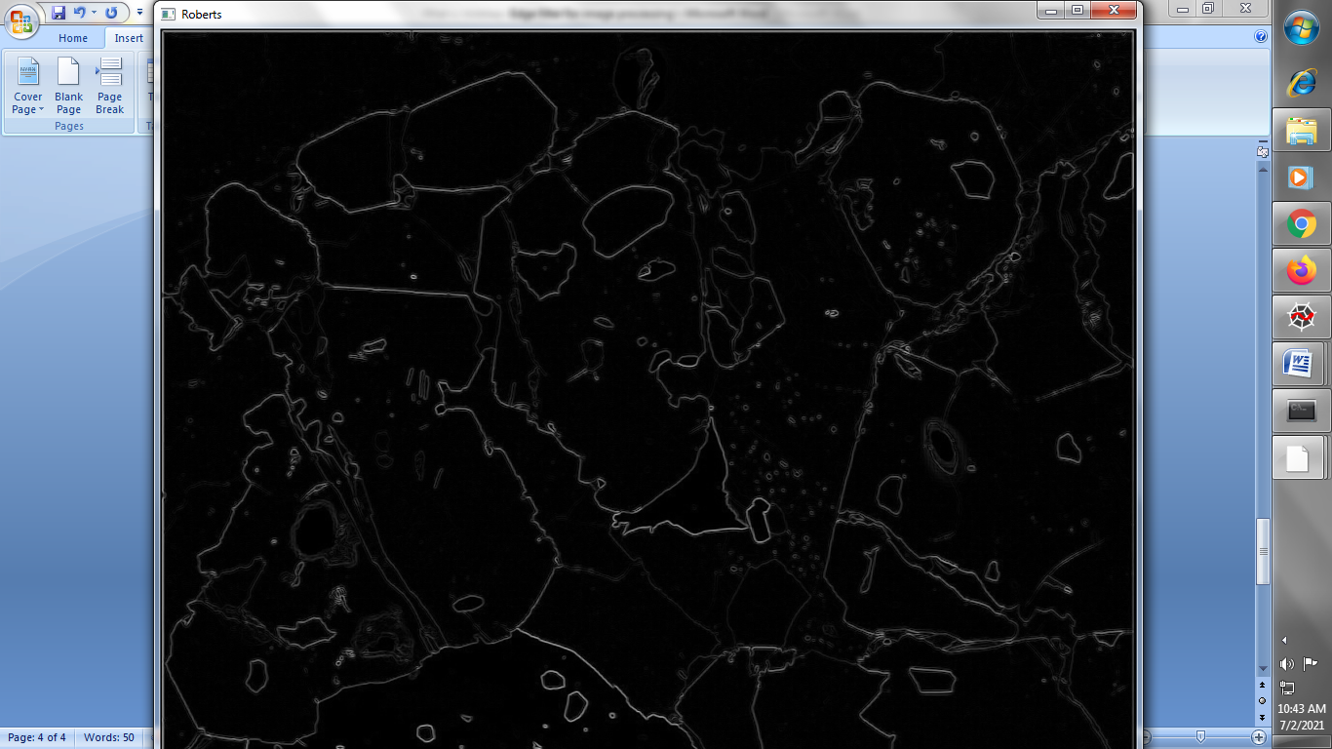

**→Sobel Filter :**

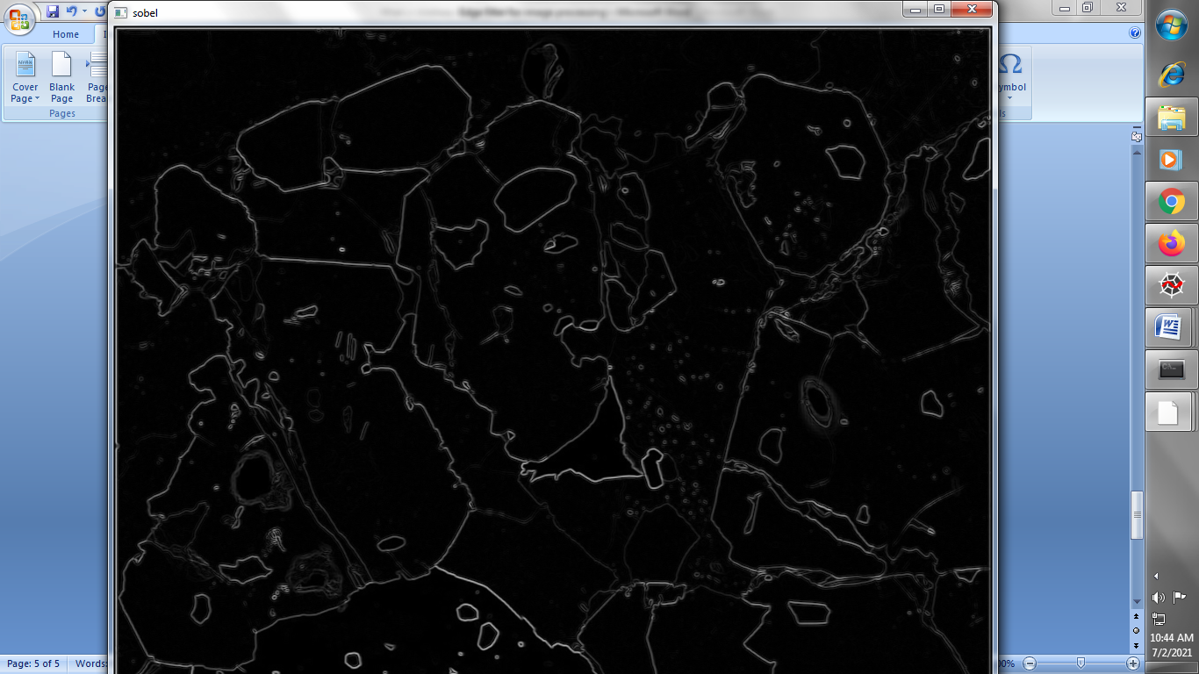

**→Scharr Filter :**

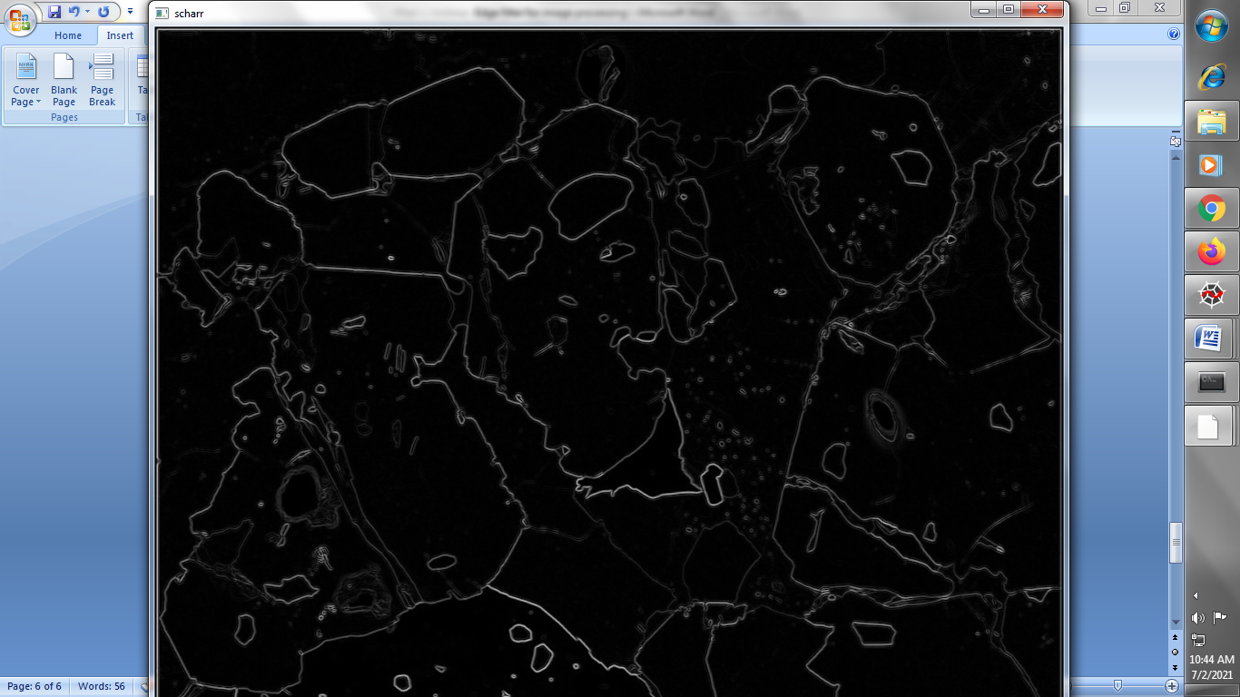

**→ Prewitt filter :**

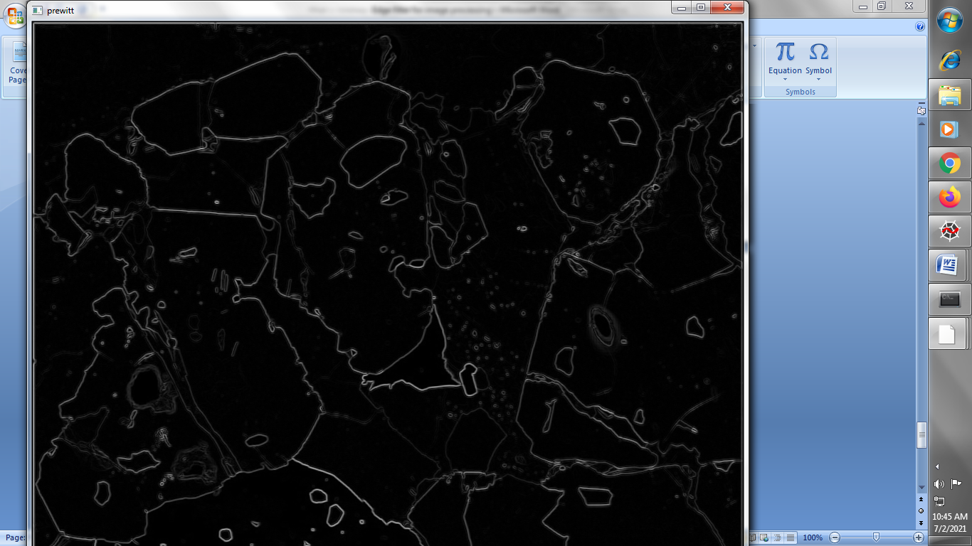

**→ Farid Filter :**

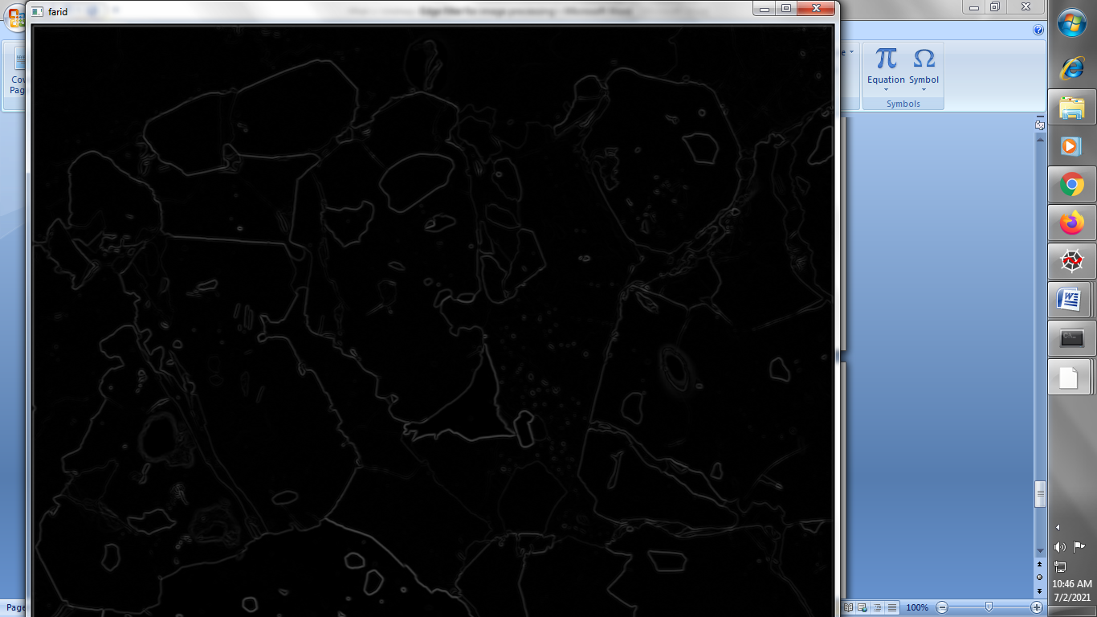

**→ Canny Filter**

1. **Read our image**

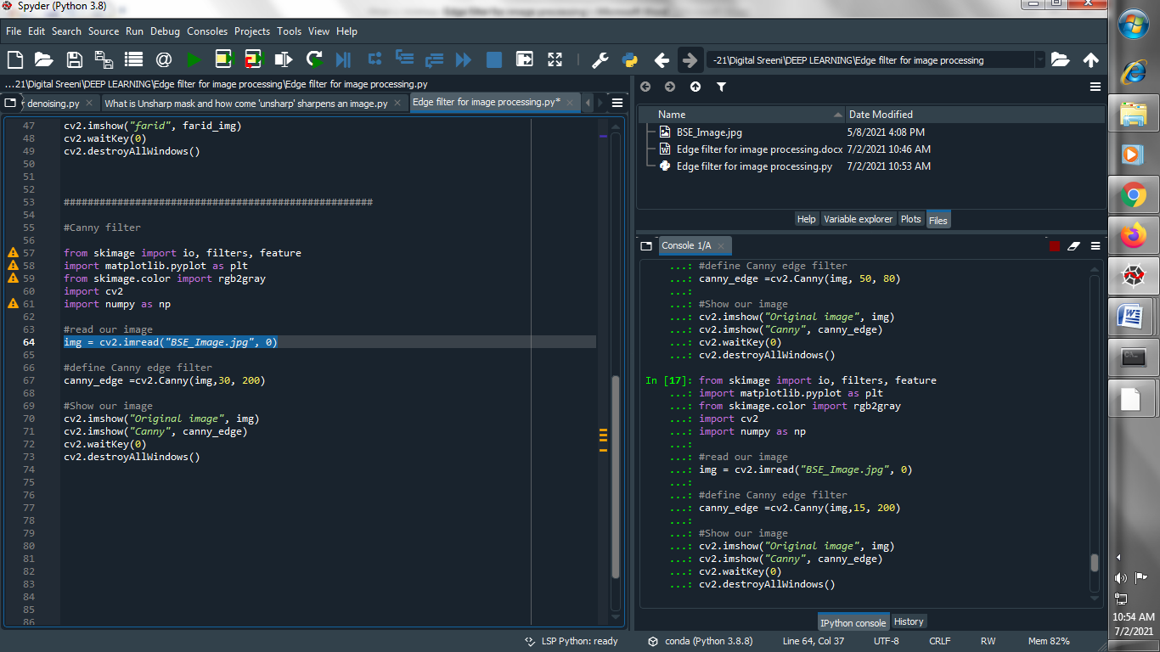

1. **Define canny edge filter :**

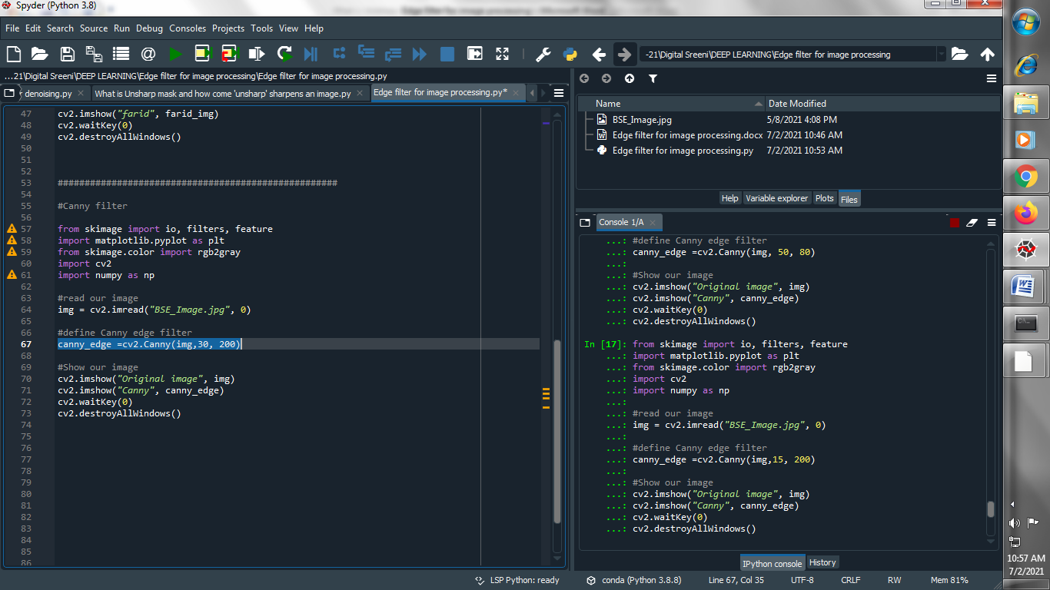

1. **Show our image :**

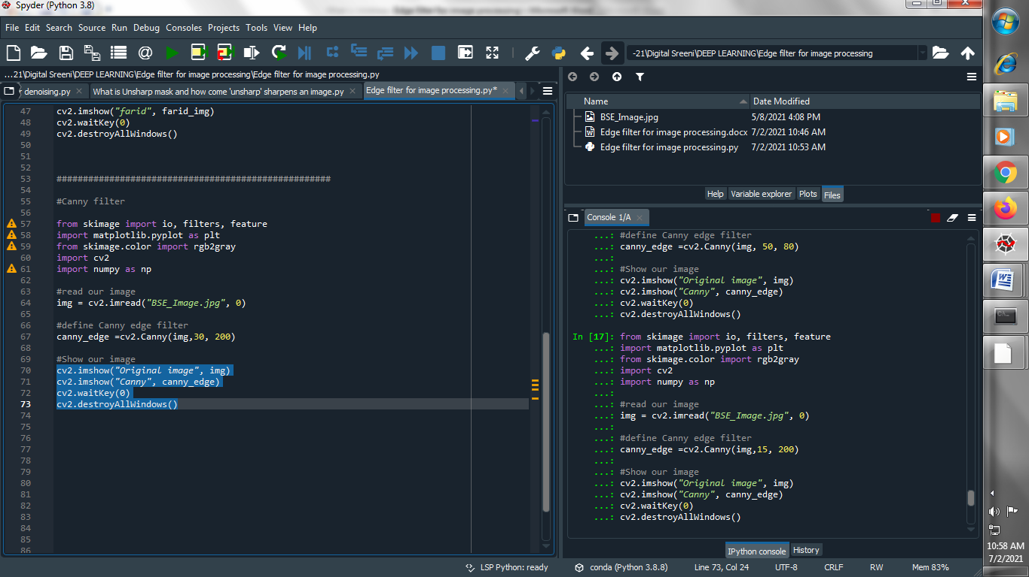

**Output :**

**Original image :**

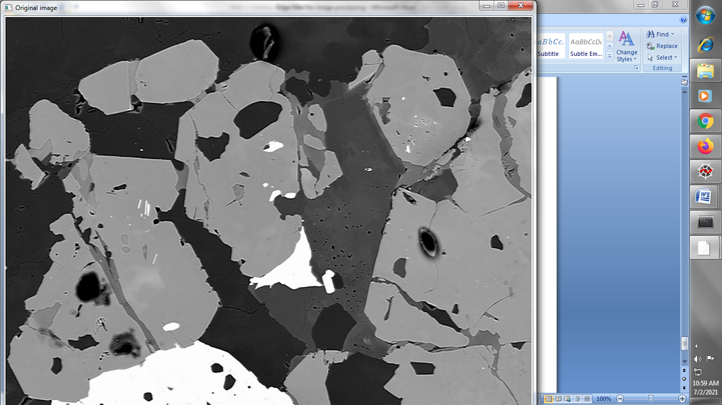

**Canny edge filter :**

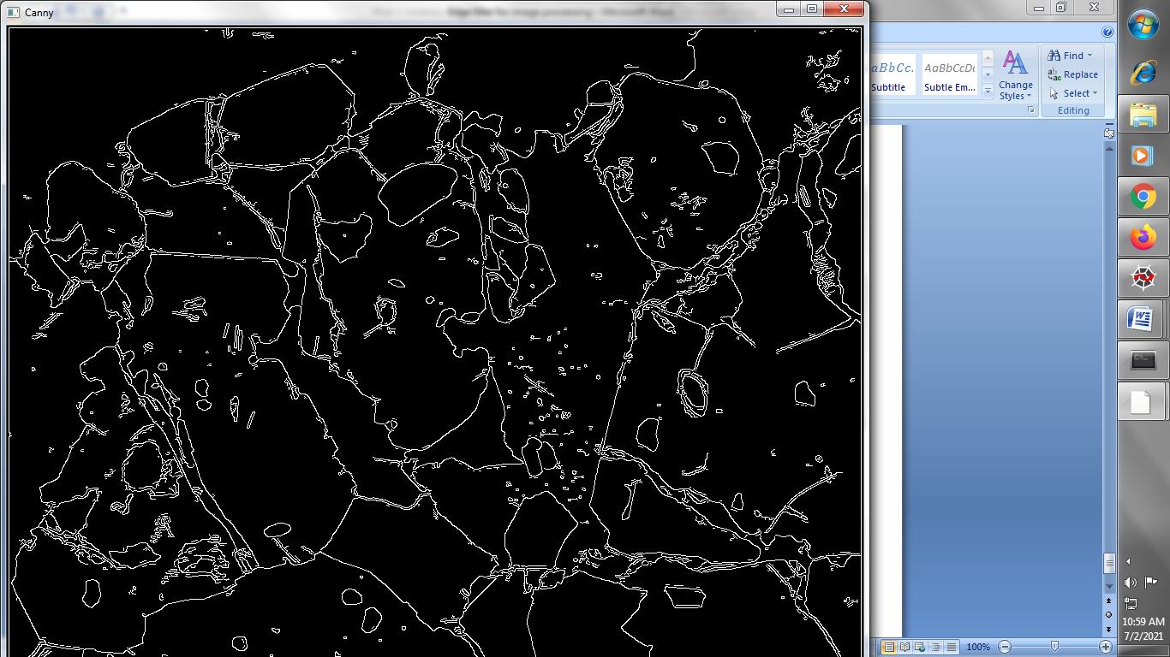

**→ AutoCanny Edge Filter :**

1. **Read our image and define canny edge filter :**

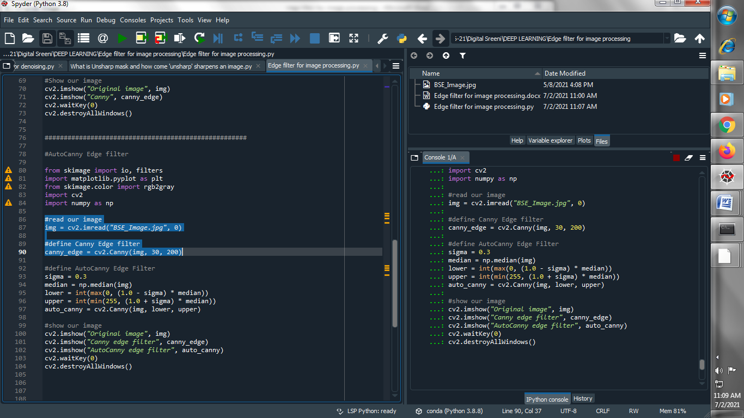

1. **Define AutoCanny Edge Filter :**

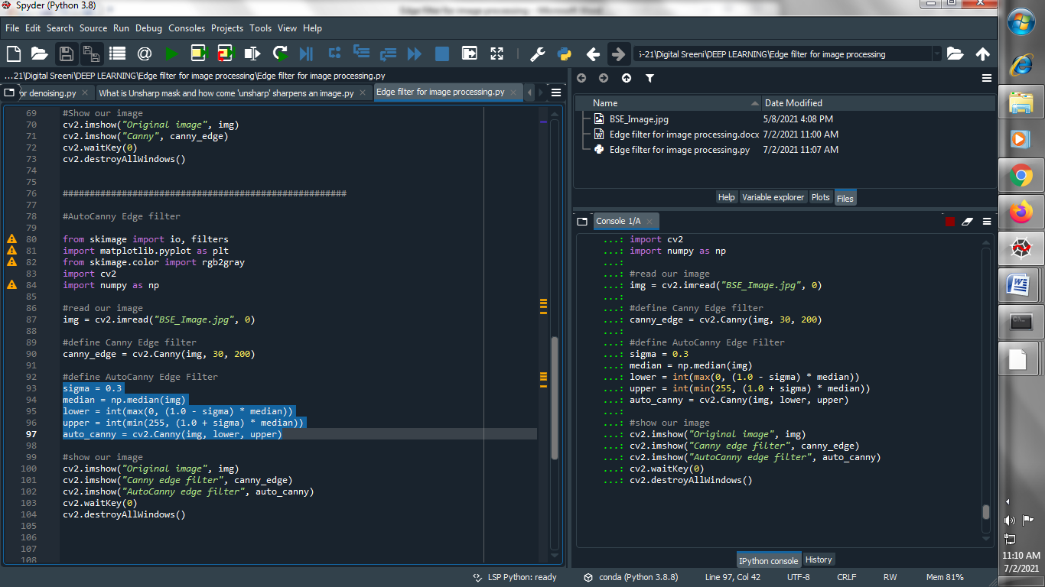

1. **Show our images :**

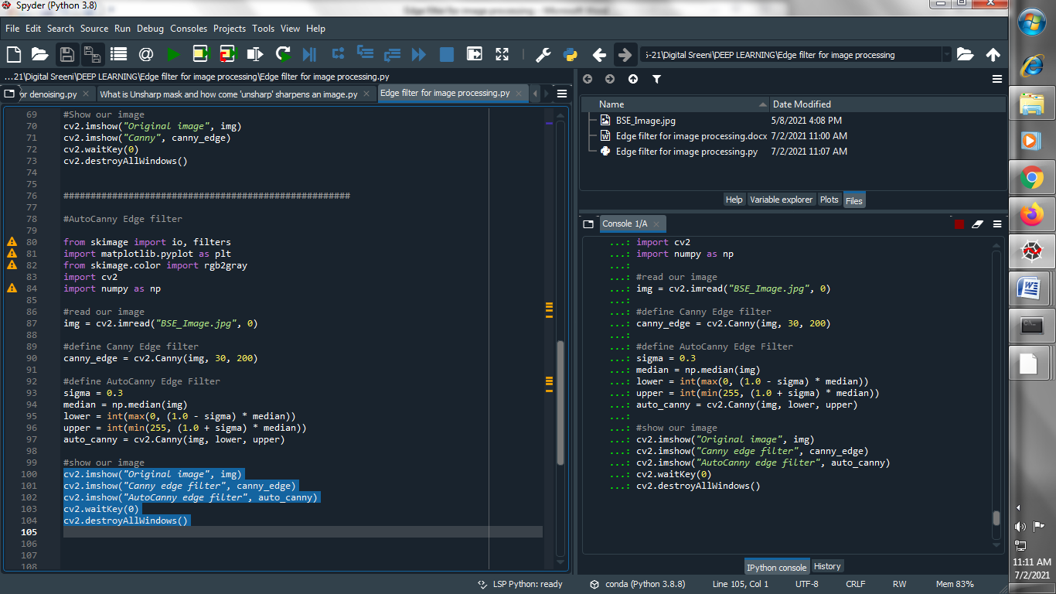

**Output :**

**→ Original image :**

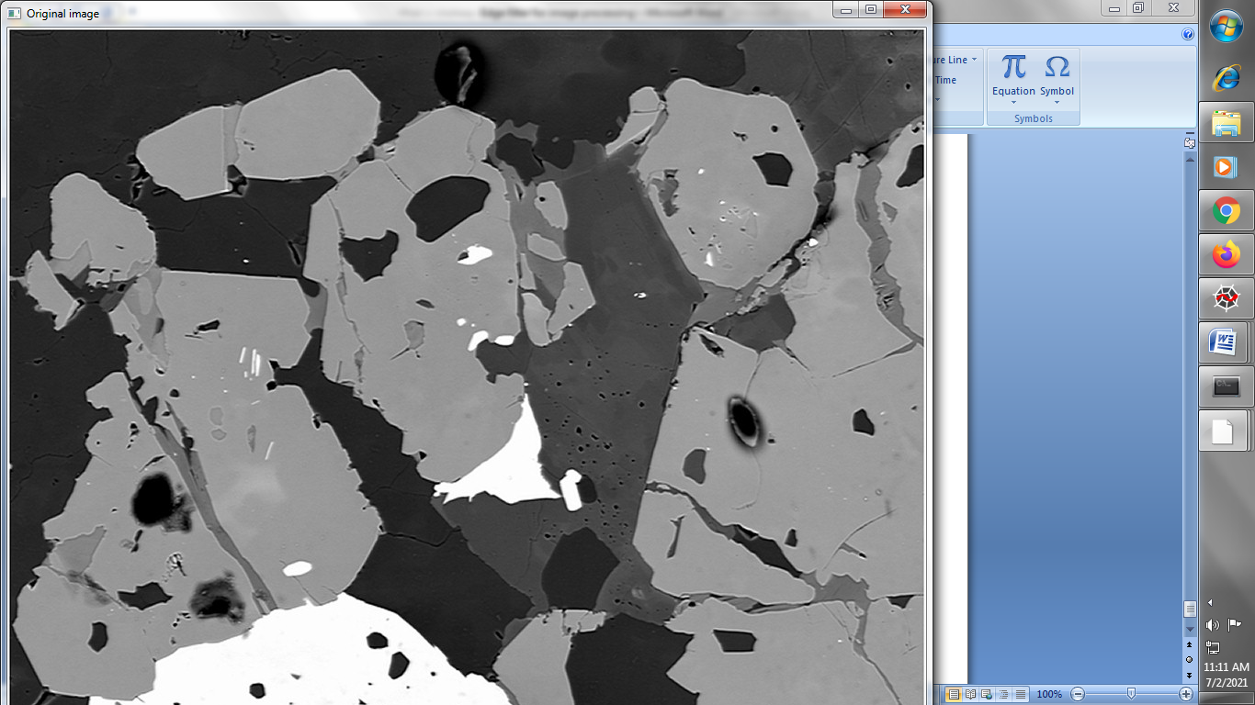

**→ Canny Edge Filter :**

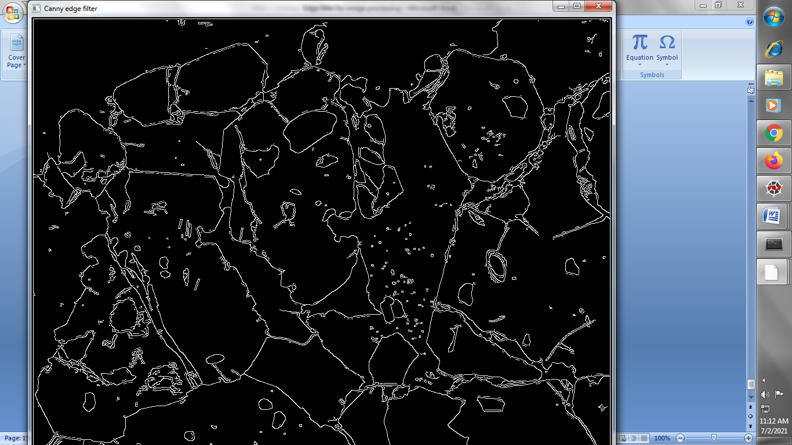

**→ AutoCanny Edge Filter :**

